Dear Parents/Carers,

The children have settled into year 3 well and we are looking forward to making this next half term an amazing term for learning. This letter will tell you the information that your child will be learning about in class. Further information about their learning can be found on our school website.

Getting Ready to Come to School
Children will need to come to school every day:
- Wearing their school uniform
- With their bookbag and water bottle
- Ready to learn!
Our Learning:
English   | In English, we will be investigating fairytale crimes! Children will be considering different view points when writing and developing their use of using speech marks. They will also be learning to write report and discussion texts within the same topic
Maths  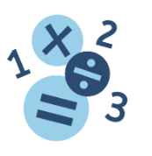 | We will be continuing to develop our multiplication and division skills and then move on to learning about length and perimeter. Pupils will also be focusing on the 4 Times Table.
Science  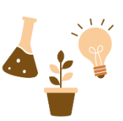 | For biology, we are learning about our diets, including what different components are in different foods. We will then learn about our skeleton and its uses, followed by finding out about the different types of skeletons in a variety of animals.
History   | This term we will be learning about Ancient Egypt. We will learn about the different discoveries made by Egyptians, and their beliefs.
Art   | In art, we will be developing our clay skills sculpting a clay tile to create a fairy tale scene.
Religion and Worldviews  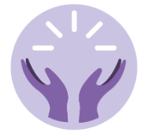 | In RE, we will be learning about Christianity and Humanism. We will be exploring how people make moral decisions, rules and human choice.
PE   | For PE, we are learning how to score points and how to use skills, simple strategies and tactics to outwit the opposition.
Music   | For Spring 2, we will focus on learning to identify rhythms in music
Computing   | In computing, pupils will be using Scratch and other apps to code and create different pieces of music.
PSHE  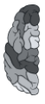 | In PSHE, we are exploring how to keep us safe. We will learn how to recognise risks and what to do in an emergency.

Below is the day your child will take part in PE.
On this day your child must wear their PE kits to school.
Jay Class – Thursday
Robin Class – Thursday
Wren Class – Thursday

There is also a cricket lesson which children will need their PE kits for
Jay Class – Monday
Robin Class – Monday
Wren Class – Monday

Homework
Each week your child will be expected to complete a range of different homework tasks to help support their learning in school. All homework will be found on our school website under the Year 3 page.
Reading | Please support your child at home in ensuring that they are reading each day independently and to you. They must also have opportunities to listen to an adult read to them.
Learning with Parents | This is a platform we use to record reading at home and in school. Please log all reading done at home on this website.
myON | Each week children are expected to log on to myON and read at home. The child who completes the most amount of reading each week will be awarded with a certificate.
Times Table Rockstars | Children are encouraged to practise their times tables weekly on Times Table Rockstars. We have weekly battles between each Year 3 class, can you help your class win?

In class we would love to celebrate the amazing work children do at home. This means that any time your child completes a piece of homework, send a photo to your class teacher on Class Dojo so it can be celebrated and rewarded. Children will receive Class Dojo points for completing their homework.

Attached to this letter you will find your child’s Knowledge Organisers. You can use the information on their Knowledge Organisers to test your child’s recall of facts and their understanding of the new vocabulary listed.

If you require any additional information, please contact your child’s class teacher on Class Dojo, who will be happy to assist you.

Thank you for your continued support,

Yours sincerely,

The Year 3 team

