Dear Parents/Carers,

We can’t believe the summer holidays are over and we’re back in school! The children have settled in well and are ready to learn. Let’s make this half term an amazing term for learning and experiences. This letter will tell you the information that your child will be learning about in class. Further information about their learning can be found on our school website.

Getting Ready to Come to School
Children will need to come to school every day:
- Wearing their school uniform
- With their bookbag and water bottle
- Ready to learn!
Our Learning:
English   | In writing, we are going to be creating poems based on the seasons. We are then going to craft quest narratives based on the Cressida Cowell stories How to Train Your Dragon. Then, we will delve into formal non-fiction writing, creating our own creatures based on Fantastic Beasts and Where to Find Them.
Reading | In reading, we will be continuing to build on the reading skills of retrieval, sequencing, predictions, defining and inference across a range of texts.
Maths  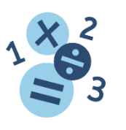 | This term in maths we are completing our study of place value, the four operations and fractions, building on our previous learning in these areas.
Science  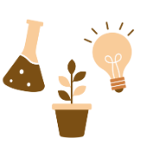 | Our science focus this half term is physics and we are studying Electricity. We will investigate variations in series circuits and how electricity is generated and supplied to our homes.
Geography   | Our focus this term is Improving the Environment where we will look at the importance of renewable energy resources and reducing waste, as well as the actions human can take to improve the environment on a local, national and global scale.
Art  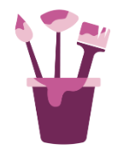 | In art, we are looking at recycled materials, using plastic waste to create an art installation about the effects of waste on our environment and the natural world.
Computing   | In computing, we will be looking at online safety and the importance of this in the modern world.
Music  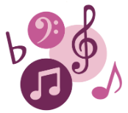 | We will be learning to sing and accompany the popular son ‘Happy’.
RE  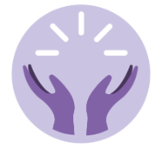 | In RE, we are focusing on Christianity and why the resurrection is significant for Christians. We will explore different gospels, truth claims and the idea of salvation.
MFL  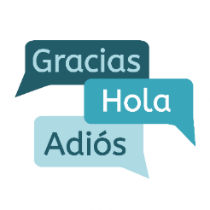 | In Spanish, we will be learning classroom instructions, telling the date in Spanish and clothing and opinions of this, using speaking, listening, reading and writing skills.
PSHE  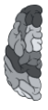 | In PSHE this term, our topic is My Connections where we will be looking at respect, manners, relationships, bullying and stereotypes whilst recapping our Growth Mindset learning powers.
PE  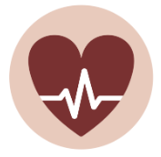 | The focus this term is Outdoor Adventure, involving leading a small group and learning to orientate and navigate using a map.

PE
Below is the day your child will take part in PE.
On this day your child must wear their PE kits to school.
Oak Class – Friday
Elm Class – Friday
Cedar Class – Friday

Homework
- Please read with your child at least 4 times a week and record it on learning with parents. Please upload pictures and audios of your child reading.
- Read your child’s library book. There are also hundreds of books available to read on MyOn!
- Practice spellings on RWInc Spelling. These will be set weekly.
- Complete any paper homework if sent home by your child’s teacher.
- Complete Learning By Questions online learning which will be set each week by the class teacher.

If you require any additional information please contact your child’s class teacher on Dojo, who will be happy to assist you.

Thank you for your continued support,

Yours sincerely,

The Year 6 team

