Properties and Changes of Materials
A material is any substance that has a name. For example: chalk, paper, wood, iron, air, water, clay, plastic, rubber, stone, leather, wax. Everything is made up of materials. When we want to make something, we need to choose the best material for the job. This unit will be focusing on the properties of materials and how their state can be changed by: heat or cold; reacting or mixing with another material; along with if they can be changed back afterwards.
Key facts | Key Vocabulary
The property of a material is something about it that we can measure, see or feel and helps us decide whether or not it is the best material. | Burning | An irreversible chemical reaction between heat, fuel and oxygen.
Most materials have more than one property and can be natural, man-made, strong, weak, heavy, light in weight, rough, smooth, shiny, dull, hard, soft, flexible, brittle, magnetic, non-magnetic, transparent, opaque, electrical conductor, electrical insulator, conductor of heat, thermal (heat) insulator, burns when heated, does not burn, melt easily or not melt easily. | Condensation | The process of water vapor turning into liquid water.
 | Conductivity | How well a material allows heat (thermal conductivity) or electricity (electrical conductivity) to pass along it or through it.
Materials exist in three states: a solid, a liquid or a gas. Materials can sometimes be changed from one state to another, perhaps by heating them – for example, ice is a solid which becomes a liquid when it’s heated. | Dissolve | To become absorbed in a liquid solution, or make a solid do this.
Some materials can be changed. They can be mixed with other materials (for example when the ingredients are mixed together to make a cake) and then changed again by heating. Because this change cannot be ‘undone’ we say that it is irreversible. Some changes, though, are reversible. For example, when ice is heated it melts and becomes water, but this change can be reversed by re-freezing the water into ice. | Evaporation | The process of a liquid turning into a gas.
 | Flexibility | The ability to bend or be bent repeatedly without damage or injury.
Changes of state:  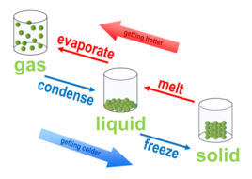 | Freezing | The process of a liquid turning into a solid.
 | Hardness | Resistance to scratching or pressure. Hardwood does not mark as easily as softwood.
 | Insoluble | Unable to dissolve.
 | Irreversible | Impossible to reverse or undo.
 | Man-made | Made by human beings and not occurring naturally
 | Melting | The process of a solid turning into a liquid.
 | Natural | Present in or produced by nature, not artificial or synthetic (e.g. wood)
 | Reversible | Able to be changed or undone.
 | Solution | A substance consisting of two or more materials mixed together.
 | Transparency | How easy it is to see through a material.

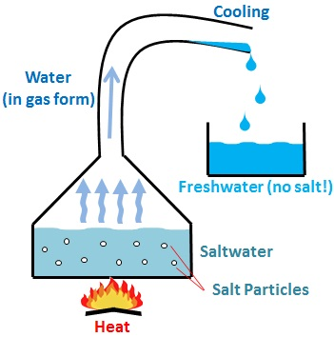  When a material has dissolved into water, you can separate the solution by heating up the water until it evaporates, leaving the material behind. | 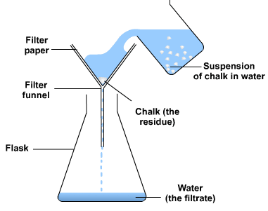  When an insoluble material is mixed into water, you can separate the mixture by pouring the solution through a filter of an appropriate size. This is call filtration.
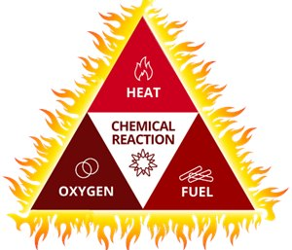
Burning is an irreversible reaction, as the original material cannot be returned to its previous state.

For something to combust (burn), there are 3 things required: A fuel source (what is being burnt), oxygen, and heat. When all of these are readily available, then the material will combust and produce a flame.

