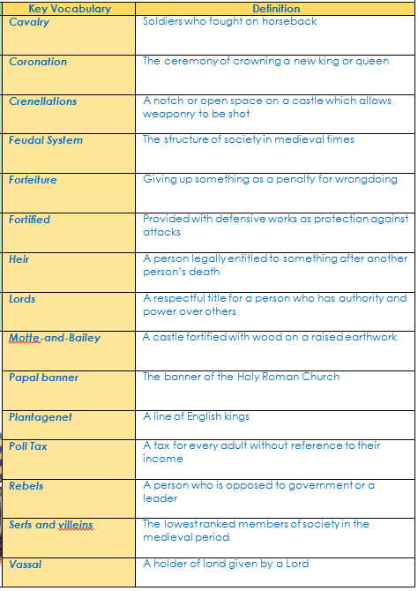
The Middle Ages, or Medieval Times, in Europe was a long period of history from 500 AD to 1500 AD. That's 1000 years! It covers the time from the fall of the Roman Empire to the rise of the Ottoman Empire. This was a time of castles and peasants, guilds and monasteries, cathedrals and crusades.

Interesting facts
In Year 4 the children gained knowledge of events leading up to the Battle of Hastings. We use what we have learned about William the Conqueror (who defeated Harold) and explore how he shaped Medieval Britain as king.
We will revisit the Bayeux Tapestry and discuss how it represents key events of the Battle of Hastings.
We will use our prior knowledge of pre 1066 and compare it to how Medieval Society was structured after the Feudal System was introduced.
- Houses were crowded and families often lived with an animal (such as a cow) inside the house
- There was laws determining what you could wear in accordance to your social class
- Very few people attended school. Instead, they often learned their job off their parents
- Peasants were not allowed to hunt on the lord’s land. If they did, the punishment for killing animals (such as deer) was often death
- People mostly drank wine or ale. The water was that unsafe it often made people sick
- A lord often had the finest house. They would eat foods which peasants would not (such as meat)
Prior Learning  Year 1:  > The role of castles in society  Year 2:  > Growth of big city with awareness of city and country  Year 3:  > Changes in dwellings from Stone Age to Medieval times  > Social hierarchy in Egyptian times |  | Following on:  Year 4:  > Follows on from the Viking Period and how their influence reduces and Norman and European rule increases  Year 5:  > Changes in settlement are a cause of the spread of the Black Death  Year 6:  > Comparing the social hierarchy of the two periods – how has it changed?
 | Key Dates/Events |  | Key People
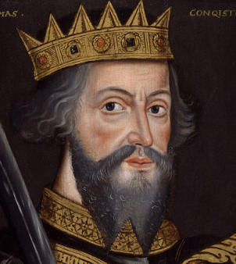  William the Conqueror  To conquer England William gathered men from Normandy, France, and even other countries in Europe. He promised them land in England for their service. He rode into battle riding a black stallion that had been given to him by the King of Spain | 1066- The Battle of Hastings  1070s- William builds Windsor  Castle  1086- Doomsday book written  1189- Richard the Lionheart  become king.  1215- John 1 signs the Magna  Carta  1215- First English Parliament  formed.  1348- The Black Death in  England  1381- Peasants’ Revolt  1485- End of Medieval Periodstart of Tudor rule |  | William the Conqueror- first Norman King of England who consolidated Norman power.  Edward the Confessor- final Anglo-Saxon king who left no heir leading to dispute of the English crown  Harold Godwinson- opposed William for the English crown.  John 1- King who signed the Magna Carta reducing King’s power.  Richard the Lionheart- famous English king who went to fight in the crusades.  Simon De Montfort- English nobleman who called for the formation of a parliament to reduce the power of the king.

